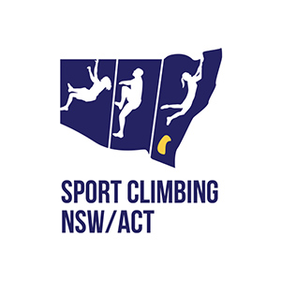
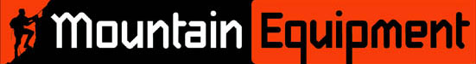

2020
NSW/ACT State Titles
Boulder
12th, 13th, 14th and 15th November
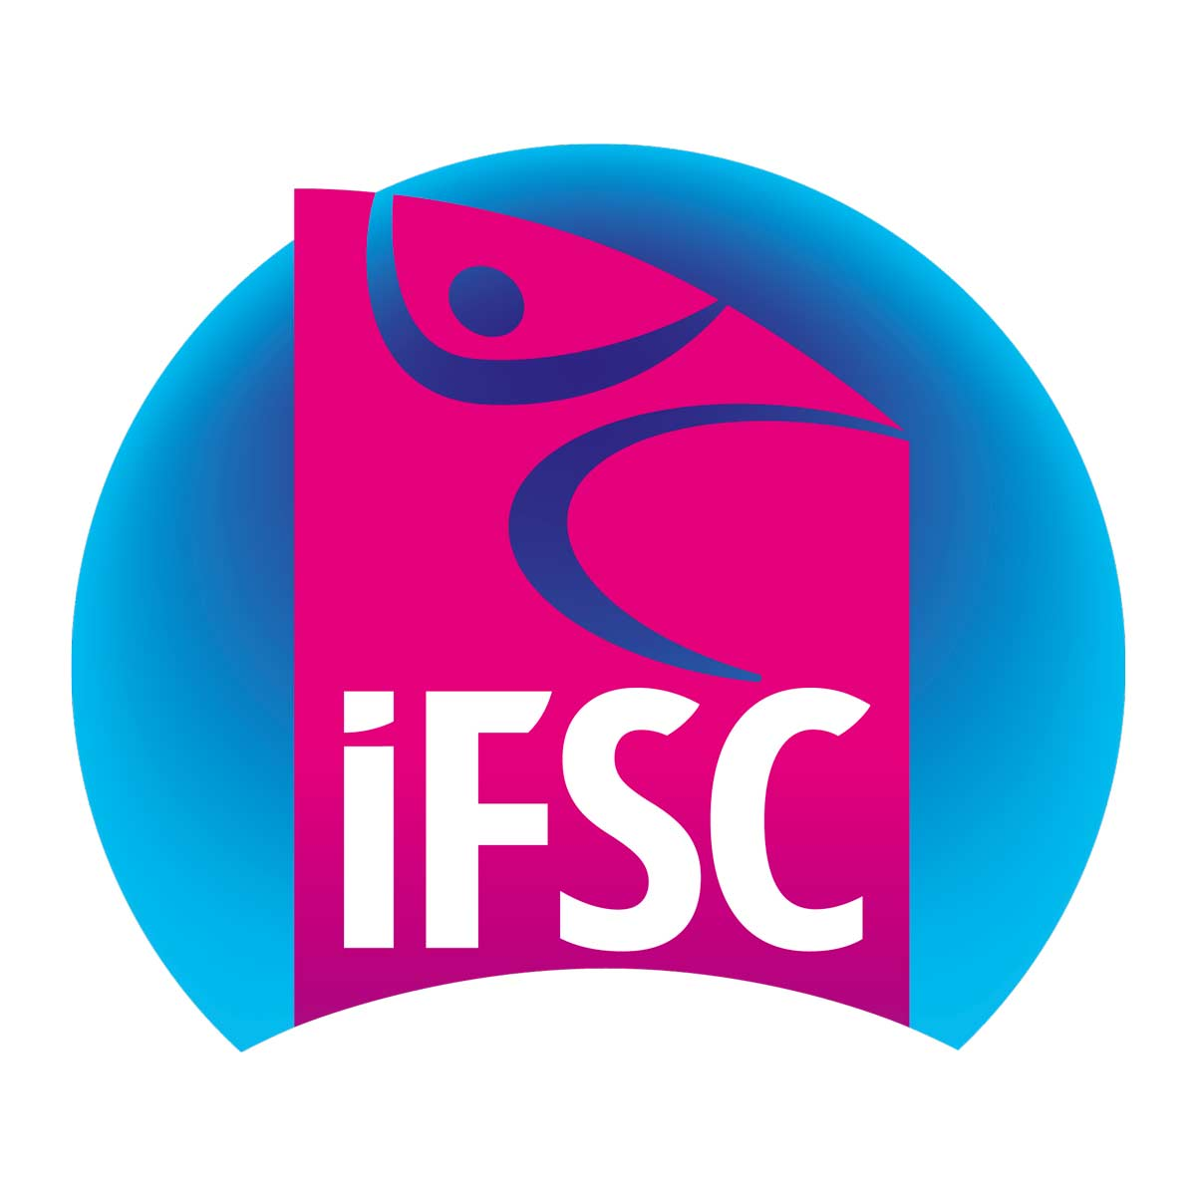
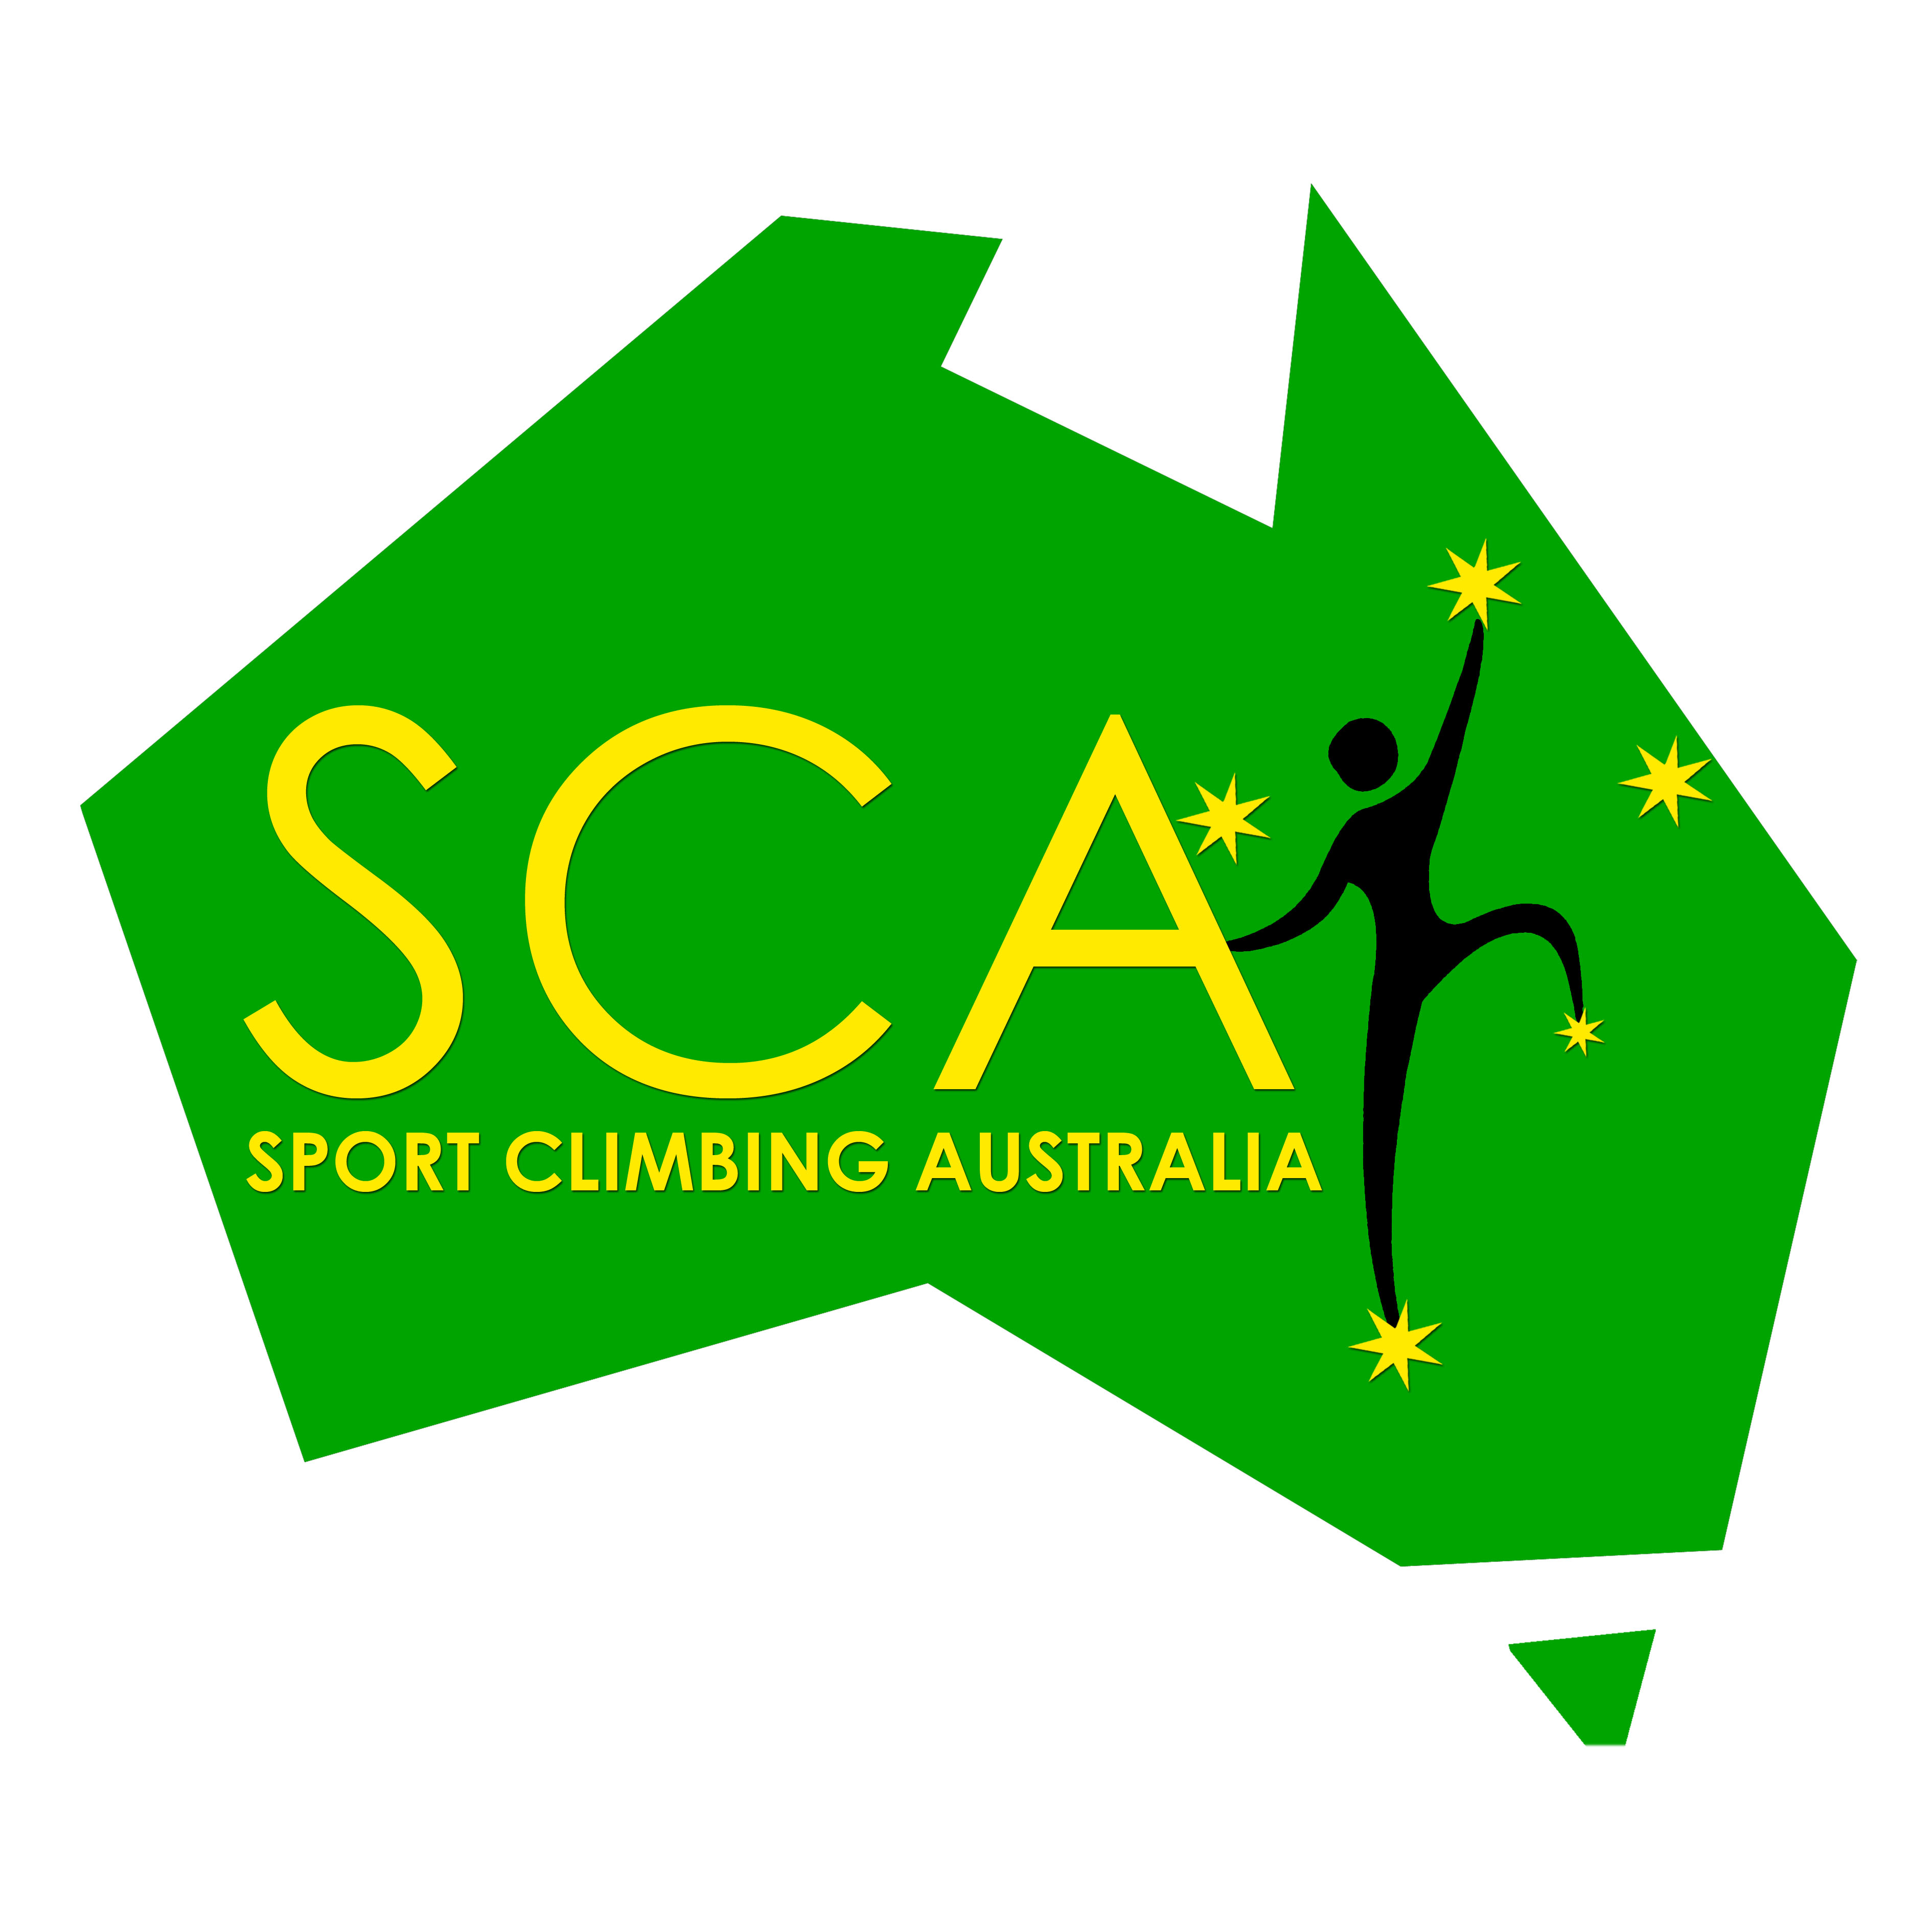

Climbers’ Handbook
This handbook is provided for the information of climbers wishing to participate in the event. The details may change.
The NSW/ACT State Titles competition will decide the NSW and ACT Champions in Bouldering for all Open and Youth categories. Top ranked climbers will be invited represent their state/territory at the National Championships in 2021.

- Dates:
The event will be held over four days:
- Thursday 12th Nov 2020 – Open B, Masters
- Friday 13th Nov 2020 – Juniors and Youth A
- Saturday 14th Nov 2020 – Open A qualifiers and finals
- Sunday 15th Nov 2020 – Youth B, C and D and Paraclimbing

- Location:
Sydney Indoor Climbing Gym Villawood
5/850 Woodville Rd, Villawood
Phone: (02) 97282825
Email: sicgvillawood@hotmail.com
Directions for parking and public transport can be found on their website:
www.indoorclimbing.com.au/villawood/

- COVID safe policies:
The event will be run according to a COVID safe plan. It is important that all competitors, volunteers and spectators abide by the rules as well as any instructions on the day by competition officials or SICG Villawood staff. Special measures will include (but are not limited to) the following:
- Do not come if you are sick or have been exposed to people who are sick, or if you have come from overseas or from a COVID hotspot without proper quarantining.
- Climbers must be pre-registered and also sign-in on the day, and any family members/spectators will need to give their details at the registration desk on the day. Please minimise the number of spectators – for example one person per competitor.
- Avoid being in the gym when it is not your session. You may arrive 45 minutes prior to your session to sign-in and warm up, and stay until the medal ceremony for your category, then please leave the gym.
- Liquid chalk and chalk balls only (inside a chalk bag). No sharing of chalk.
- Use hand sanitiser and wash hands regularly.
- No spectators in the boulder area whatsoever. Only competitors, judges and route setters allowed, and only competitors in the current session (once they are called).
- Maintain social distancing throughout the gym at all times, including in isolation and outside of competition sessions. No waiting on or near the stairs. Climbers finishing a session should leave the boulder area immediately, and climbers in the next session should wait in the most open / least crowded section of the gym until their category is called.
- During the boulderjam sessions, avoid crowding around the judges
- Face masks to be worn by volunteers and officials. Face masks optional for climbers.

- Categories:
Important note: Youth competitors will now compete in the category that applies at the next youth nationals – in 2021. Check your category carefully as it may not be the same one you were in for 2020 lead/speed titles. Those who will be eligible to compete in Masters in 2021 may compete in Masters for this competition as well. For further explanation see this document.

There will be male and female categories in:
- Open A – higher level open climbers
- Open B – climbers born 2001 or earlier climbing up to grade V6 (male) and grade V4 (female) as a guideline
- Masters – born 1981 or earlier
- Junior – born 2002/2003
- Youth A – born 2004/2005
- Youth B – born 2006/2007
- Youth C – born 2008/2009
- Youth D – born 2010 or after

Youth A and Juniors Competing in Open A
Youth A and Junior competitors wishing to also compete in the Open A category will be required to register and pay for Open A as well as their respective categories. Junior/Youth climbers are not permitted to climb in Open B.

5. Registration:
5.01 All competitors must be current NSW/ACT State or National members of Sport Climbing Australia. Join at the SCA website. http://www.sportclimbingaustralia.org.au/join-us

5.02 Climbers are required to pre-register on the Sport Climbing Australia website. Registration at the venue on the day is not available. Visit https://sportclimbingaustralia.org.au/Upcoming-Events

5.03 Competitors visiting SICG Villawood for the first time are required by the venue to complete the SICG Villawood waiver form. This is a separate process to the competition registration through SCA, and should be done in advance of the competition to avoid delays on the day.

5.04 Entry fee
- The entry fees are published on the SCA website.
- The fee is greatly reduced from last year

5.04 Climbers who are colour-blind need to notify the route setters through Sydney Indoor Climbing Gym Villawood at least one week prior to the event.

6. Competition Format:
The competition will be run according to SCA rules and policies which can be found here. Refer to the SCA guidelines for definitions of the following terms.

6.01 Climbers in Open A will compete in a boulderjam style qualifier for all registered competitors, followed by World Cup finals format for the top six ranked climbers per gender. Climbers must participate in the qualifying round to make finals even if there are less than 6 competitors in the category.

6.02 All other categories will compete in a boulderjam only.

6.03 NSW/ACT State Champion in each category will be decided according the the SCA rules. Podium places and medals will be awarded for each category as a combined event (i.e. first, second and third overall) however placing for national ranking and team selection will be separated according to state/territory.

7. Event Regulation
7.01 To compete in this State Competition the climber agrees to follow all rules and regulations outlined in this information pack and follow the rules and procedures of the hosting gym.

7.02 This competition will run in conjunction with the Sport Climbing Australia and IFSC rules. Please find the full rules and regulations at the SCA website.

7.03 Specific rules and procedures for this event will be detailed in the briefing period before the commencement of each round of competition. Any questions or clarification regarding the rules must be asked during this time.

7.04 Event Officials
Event Organiser: Sport Climbing NSW/ACT
Jury President: Rob Le Breton
Head Judges: Matthew Klein
Head Route Setter: Carlie Le Breton
Any complaints or contests can be directed to the Head Judge on the day. Queries regarding routes and technicalities can be directed to the head route setter.
Questions regarding format, registration and any other queries can be directed to the event organiser.

8. Volunteers
- This event is made possible only through the generous efforts of sponsors and volunteers. We are always looking for volunteers to help as judges and general helpers.
- Even if you are competing it is possible to volunteer at other times during the weekend
- If you are interested in volunteering please follow this link to register.
9. Interim Timetable:
The following timetable is a draft and subject to change.
- Times are approximate and will vary depending on the running of the event.
- Climbers are advised to be at the event and ready to climb at all times.
- You can also check our facebook page for updates, news and run orders on the day of the competition:

Thursday 12th Nov (Open B, Masters)
4:15pm Sign-in opens
5:00pm to 7:00pm Open B Male,
7:00pm to 9:00pm Open B Female, Masters Male and Female
Medals ceremonies to follow each wave.

Friday 13th Nov (Youth A and Junior)
4:15pm Sign-in opens
5:00pm to 7:00pm Junior Male and Youth A Female
7:00pm to 9:00pm Junior Female and Youth A Male
Medals ceremonies to follow each wave.

Saturday 14th Nov (Open A)
10:15am Sign-in opens
11:00am to 1:00pm Open A Female qualifier
1:30pm to 3:30pm Open A Male qualifier
6:00pm to 9:00pm Open A Male and Female finals
Medals ceremony to follow finals

Sunday 15th Nov (Youth B, C, D, Paraclimbing)
8:15am Sign-in opens
9:00am to 11:00am Youth D Male and Female and Paraclimbing
11:30am to 1:30pm Youth C Male and Female
2:00pm to 4:00pm Youth B Male and Female
Medals ceremonies to follow each wave.

