2022

Victorian State Bouldering Titles

brought to you by Boulder Lab

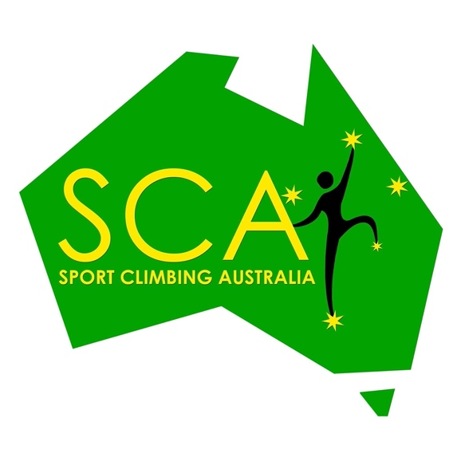
Infopack

Sport Climbing Victoria acknowledges the sovereign rights of the Wurundjeri people of the Kulin Nations, on land we live, work, play and recreate

Sport Climbing Victoria is committed to promoting and protecting the safety and wellbeing of children and young people, by providing a child safe environment where children and young people are safe and feel safe.

1 Location, Date and Contact information

Address
The Victorian Youth Boulder Titles 2022 will be held at Location:
Boulder Lab Ferntree Gully - Unit 8/1821 Ferntree Gully Rd, Ferntree Gully VIC 3156 (https://boulderlab.com.au/)
Phone: (03) 8719 6444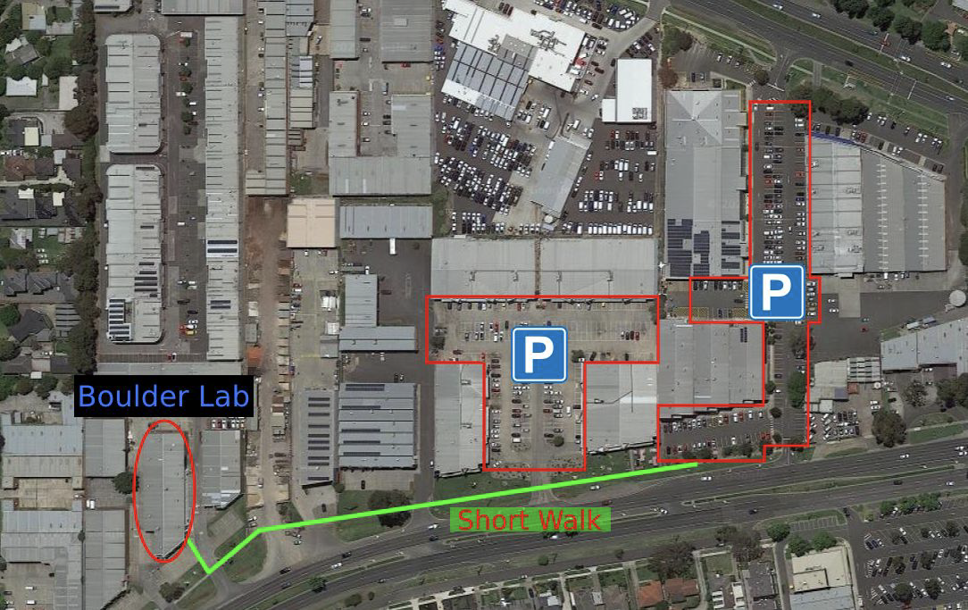

Parking:
Please note, as we are expecting a large number of competitors and spectators our car parking will fill up. There is plenty of alternative car parking a short walk away (200 meters). Please be aware that other businesses are operating in the area, so please avoid parking in their parks.

Date
Saturday 15th October 2022

Contact Information
Email and Competition Enquiry:
- Sport Climbing Victoria: contact@sportclimbingvictoria.com.au

- Registration, please find relevant event:

https://www.sportclimbingaustralia.org.au/event-4972833

Event Format & Information

2.1 Registration and Fees
Registration for the competition will be online only on the Sport Climbing Australia website
Please note there will be two different entry costs for the event:
- Normal Price (until midnight 8/10/22): $60
- Last Minute (from 8/10/22 until close of the registration on 13/10/22): $80

All competitors must be either SCV state members (if from Victoria) or SCA national members (if from interstate) - membership is available online at www.sportclimbingaustralia.org.au

2.2Groups
Open A and B, Masters, Para-climbing, Inclusion, Youth A, B, C, D and Junior

See age groups in Section 3 – Categories

2.3 Timetable (FINAL)
Please note that the timetable may be subject to change ON THE DAY, so please listen to all announcements and officials.

6:45 am | Gym opens and Registration opens and will remain open. Please arrive at least 30 mins before the start of your Boulder Jam
Qualifications
7:15 am  8:00 am – 10:00 am  10:30 am | Athletes and Judges briefing  Boulder Jam: Youth B, C and D  Podium for Youth C and D
10:15 am - 12:15 pm | Boulder Jam: Youth A, Junior, Open B
12:30pm - 2:30pm | Boulder Jam: Open A, Para-climbing, Masters & Inclusive
Final  3:15pm  3:25pm | Judges Briefing  5on/5off: Youth B  (Isolation will be open at 2:40pm and close at 2:55pm)
Final  4:35 pm | 5on/5off: Youth A  (Isolation will be open at 3:50pm and close at 4:05pm)
Final  5:45 pm | 5on/5off: Junior  (Isolation will be open at 5:00pm and close at 5:15pm)
Final  6:55 pm | 5on/5off: Open B  (Isolation will be open at 6:10pm and close at 6:25pm)
Final  8:05 pm | 5on/5off: Open A  (Isolation will be open at 7:20pm and close at 7:35pm)

  - Event Format

Event format will be held in accordance with the Sport Climbing Australia Competition Policy for Bouldering State Titles with the following:

- SCA competition rules Level 2 Boulder Jam format
  - Para-climbing, Masters, Youth C, Youth D, Inclusion under 16 and over 16

- SCA competition rules Level 3a Boulder Jam followed by 5on/5off Final
  - Open A Male and Female, Junior, Youth A and Youth B

Complete rules for the event can be viewed at the Sport Climbing Australian Competition Policy page: http://www.sportclimbingaustralia.org.au/page-18117

  - Event Officials

Jury President TBD
Head Route Setter Pat Klein
Setting Team TBA

  - Volunteers

This event requires volunteers so if you would like to participate as a volunteer, please use the below weblink to register your interest:
https://docs.google.com/forms/d/e/1FAIpQLSfHYpyNq_XbVG8VRtNBlHY4qVA-OkQ24c20R57YAWzK1GSe9w/viewform

Volunteer positions include:
- Judges, Isolation stewards, Registration desk, and First Aid.
- All training for these positions will be provided by SCV free of charge with the possibility of being recognised at a National Level as a volunteer.

Note: All volunteers must be holders of a Working With Children’s Check (WWCC). If you do not hold a WWCC then SCV can help in obtaining a Volunteer WWCC.

Categories

Youth D – born 2012 -2015
Youth C – born 2010 – 2011
Youth B – born 2008 - 2009
Youth A – born 2006 - 2007
Junior – born 2004 - 2005
Inclusive Over 16 – born after 2006
Inclusive Under 16 – born before 2006

The Inclusive category is designed for climbers who don’t climb in the gender binary categories. We celebrate and encourage climbers who identify as non binary and/or gender fluid and/or those keen to climb in a category that does not recognize gender as binary.

Masters - born 1983 or before
Open A - born 2003 or before Male (V6 & above) Female (V5 & above)
Open B - born 2003 or before Male (V0 – V5) Female (V0 – V4)

Paraclimbing

Anyone wanting to climb in Para boulder please contact Ellen on ellenwhitemackenzie@gmail.com or Yvette on secretary@sportclimbingvictoria.com.au

Interstate competitors
Interstate competitors are allowed to compete but are not eligible for titles. They are eligible for ranking and prizes.

Foreign Competitors
Foreign competitors are welcome to compete. Foreign competitors will be eligible for prizes but not for an Australian ranking. Foreign climbers must also be members of Sport Climbing Australia.

COVID-19 Safe practices - https://www.coronavirus.vic.gov.au/staying-safe

Hygiene
Good hygiene is critical for slowing the spread of COVID-19. Everyone should be taking the following hygiene actions:
- wash your hands regularly with for at least 20 seconds, using soap and water or use a hand sanitiser that contains at least 60 percent alcohol
- wash your hands when you get home, arrive at other people’s homes, at venues or at work
- wash your hands after blowing your nose, coughing, sneezing, or using the toilet
- cover your nose or mouth with a tissue when you cough or sneeze, then throw it away and wash your hands. If you do not have a tissue, cough or sneeze into your elbow or upper sleeve
- avoid touching your eyes, nose, and mouth with unwashed hands
- if you are wearing a face mask, leave it on
- do not share drink bottles, glasses, crockery, or cutlery other than with people you live with
- remember to clean and disinfect high-touch surfaces regularly.

Face masks
Face masks can stop or slow viruses spreading in the air when you talk, cough, sneeze and laugh. That’s why wearing a high-quality and well-fitted face mask can help protect you and those around you from COVID-19.

Maintain your physical distance
- Greet people with a smile or wave - do not shake hands, hug, or kiss as a greeting.
- Stay 1.5 metres away from people where you can.
- Avoid crowds as best you can, especially indoors.
- When waiting in line or walking through busy areas, be patient, give others space so they can give you yours.
Checklist for attending the event
- take a rapid antigen test if you are visiting someone who is at a high-risk of severe illness from COVID-19
- stay home if you are sick or experiencing COVID-19 symptoms
- try to spend more time outdoors than indoors. Avoid poorly ventilated spaced, crowded indoor settings and prolonged contact with others
- always cover your cough and sneeze into a tissue or a bent elbow
- keep a note of people you have visited in a gathering so you can contact them in case you get COVID-19.

